

MILESTONE THREE

Group 6. TUES-18:30-2

Mladenov, Nicholas (s3539747)

Giorady, Muhammad Fathur (s3737757)

Duong, Thanh (s3601172)

Abenayake, Gihan (s3779792)

COSC2299 - Software Engineering Processing Tools

**SEMESTER TWO 2020**

**Submitted to**

Lawrence Cavedon

**CONTRIBUTION**

Duong, Thanh (S3601172) 20%:

* SEPT- 3
* SEPT- 4
* SEPT- 23
* SEPT- 46
* SEPT- 49
* SEPT- 85
* SEPT- 86
* SEPT- 87
* SEPT- 91
* SEPT- 108
* SEPT- 109
* SEPT- 111
* SEPT- 114
* SEPT- 130
* SEPT- 131
* SEPT- 132
* SEPT- 133
* SEPT- 134
* SEPT- 135
* SEPT- 136
* SEPT- 137
* SEPT- 138
* SEPT- 141
* Acceptance Test Report
* Refactoring Report

Abenayake, Gihan (s3779792) 20%:

* Product Backlog Grooming
* SEPT-53
* Meeting Minutes
* Conversation Backlog exporting
* User Story management for sprints, Ie. Context, Constraints, Scenarios and Criterions
* Project Report Creation
* General Organisation

Giorady, Muhammad Fathur (s3737757) 20%:

* SEPT- 16
* SEPT -17
* SEPT-33
* SEPT-32
* SEPT-33
* SEPT-67
* SEPT-71
* SEPT-74
* SEPT-75
* SEPT-78
* SEPT- 107
* SEPT-125
* SEPT-126

Mladenov, Nicholas (s3539747) 40%:

* SEPT- 70
* SEPT- 74
* SEPT- 78
* SEPT- 93
* SEPT- 94
* SEPT- 95
* SEPT- 96
* SEPT- 97
* SEPT- 98
* SEPT- 99
* SEPT- 100
* SEPT- 101
* SEPT- 102
* SEPT- 103
* SEPT- 104
* SEPT- 110
* SEPT- 113
* SEPT- 116
* SEPT- 117
* SEPT- 118
* SEPT- 119
* SEPT- 120
* SEPT- 121
* SEPT- 122
* SEPT- 123
* SEPT- 124
* SEPT- 127
* SEPT- 128
* SEPT- 129
* SEPT- 139
* SEPT- 140
* SEPT- 142

SCREENSHOTS

*Larger versions are present in the docs folder

Register

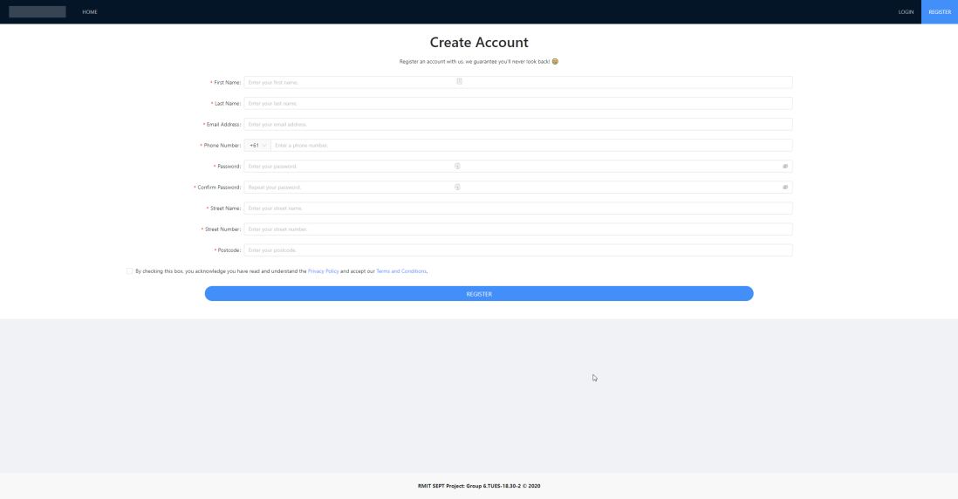

Login

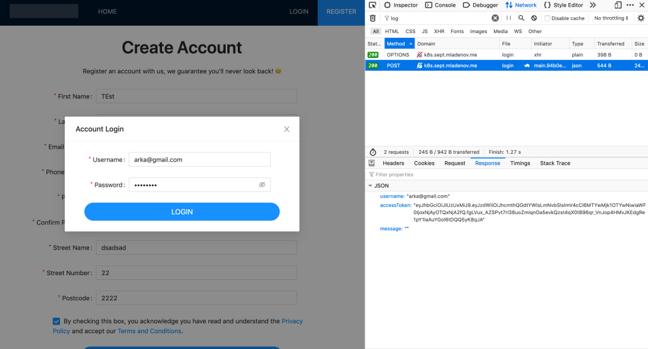

Profile

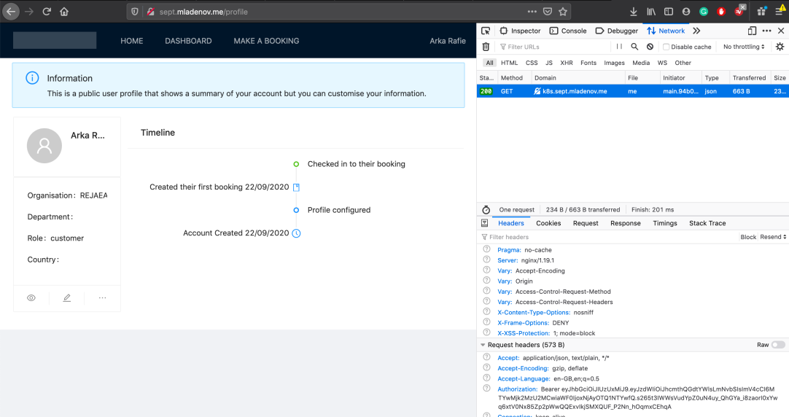

Dashboard

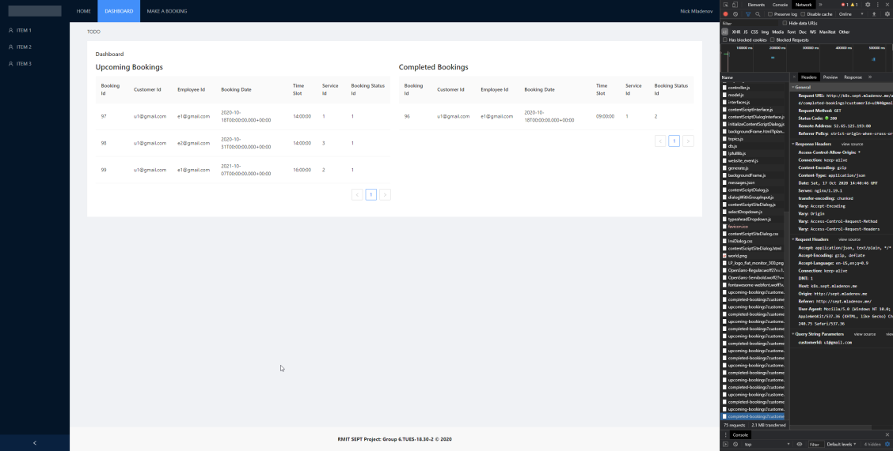

Booking

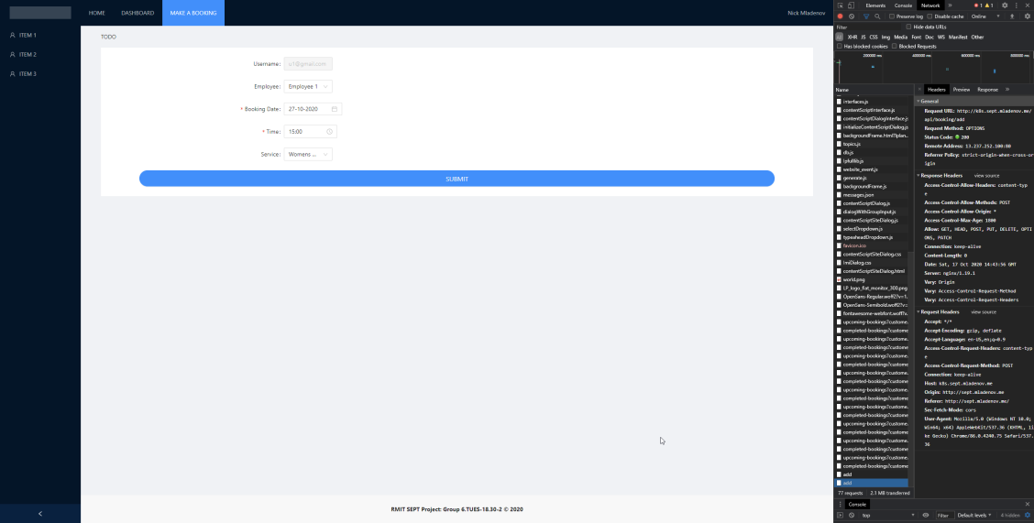

**LINKS AND RESOURCES**

Github

<https://github.com/RMIT-SEPT/majorproject-6-tues-18-30-2>

Jira

<https://s3737757.atlassian.net/jira/software/projects/G6T132/boards/1>

Database Schema v.3

<https://liveuml.com/view/5f51496e5a97dc06484a2546>

Website Wireframe v.1:

<https://app.lucidchart.com/invitations/accept/6e87cc96-f1b3-42ff-9bd1-69c2fff48973>

WEBSITE LINKS

Website Link (Note: Run by Nicholas (**s3539747**))

http://sept.mladenov.me/

PIPELINE LINKS

Website Pipeline:

<https://dev.azure.com/s3539747/SEPT/_build?definitionId=1>

Registration Pipeline:

<https://dev.azure.com/s3539747/SEPT/_build?definitionId=3>

Authentication Pipeline

<https://dev.azure.com/s3539747/SEPT/_build?definitionId=2>

Dashboard Pipeline

<https://dev.azure.com/s3539747/SEPT/_build?definitionId=4>

User Profile Pipeline

<https://dev.azure.com/s3539747/SEPT/_build?definitionId=5>

AWS Deployment

<https://dev.azure.com/s3539747/SEPT>

TESTING LINKS

*Larger images in docs folder

Authentication

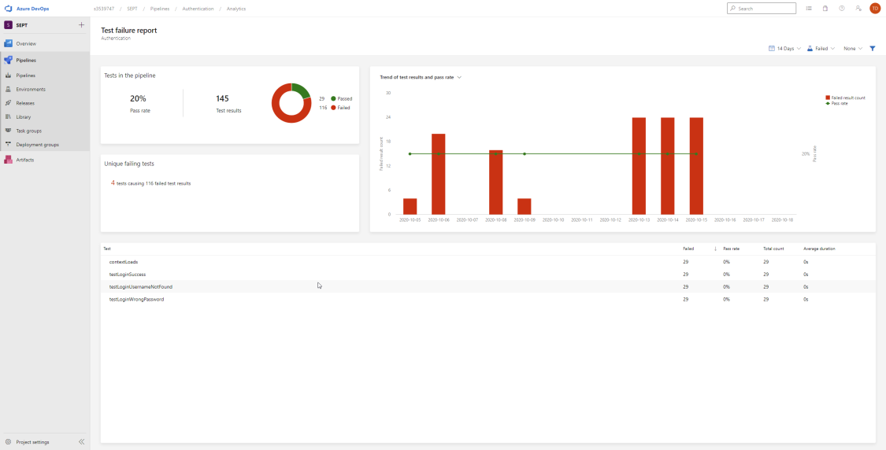

Booking

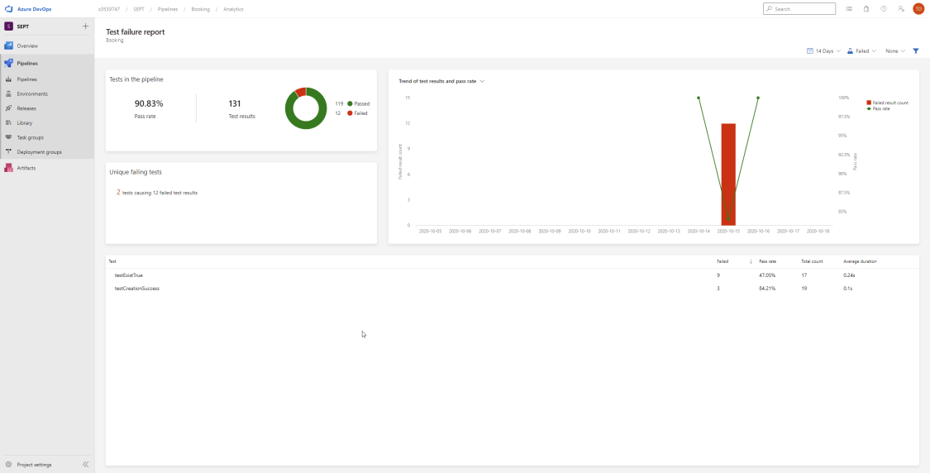

Website**:**

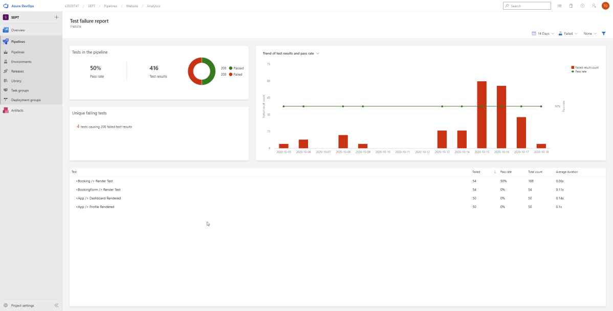

Dashboard

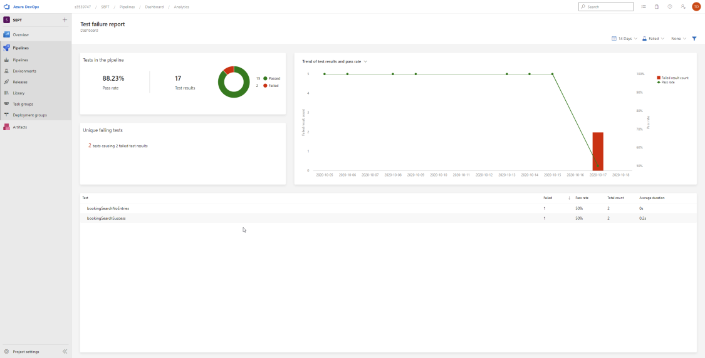

*Please note that communication done with the team and product owner is done via Microsoft Teams and team communication is done via a private Discord server. Chat-logs have been provided for proof.*